Paper-1

Introduction

Advancements in deep learning and computer vision have acceler
ated the digital transformation of agriculture, particularly in disease and
anomaly detection [3,5,16,49]. In this context, object detection models
are commonly divided into two categories: two-stage and one-stage
detectors. Two-stage detectors, such as the region-based convolutional
neural network (R-CNN) family, prioritize accuracy by first generating
region proposals and then performing detailed classification. For
instance, Wu et al. [43] developed an enhanced Faster R-CNN (TbHM-R-
CNN), achieving 96.2 % accuracy in leaf disease detection—5% higher
than the baseline—albeit with limited real-time applicability. Similarly,
Cui et al. [12] incorporated VGG16 as the backbone of Faster R-CNN and
detected weeds with 88.69 % accuracy, though at a lower inference
speed compared to YOLOv7.

In contrast, one-stage detectors, such as the You Only Look Once
(YOLO) series, have become increasingly favored for real-time appli
cations due to their streamlined architecture and inference speed. A
growing body of research have demonstrated the effectiveness of YOLO-
based optimizations in agricultural scenarios. Fan et al. enhanced
YOLOv5 for cotton weed detection (+9.1 % accuracy) [18], and Bist
et al. achieved 98.9 % mAP@0.50 for egg cluster detection using an
improved YOLO model [8].

2.2 Data construction
This study employed LabelImg annotation software to label the

Seedling
growth was monitored using Hikvision industrial cameras and laptop
computers. Cameras were mounted on the horizontal movement module

Maximum horizontal bounding boxes were used to individually enclose
each colony in the images, and the annotation format was saved as
YOLO-formatted txt files.

The dataset was then divided into three sub
sets in a 70 %:15 %:15 % ratio, designated as Groups 1, 2, and 3. To
prevent data leakage [7,17], data augmentation was applied to only
Group 1. The augmentation techniques included turning over, zooming,
tone adjustment, random flipping, addition of Gaussian noise, and hue
adjustment to enhance data diversity and improve the model’s gener
alization ability. This process generated a total of 4,380 RGB images.
Finally, the augmented Group 1 data were used as the training set, and
Groups 2 and 3 served as the validation and test sets, respectively.

2.2. YOLO-DDS
The YOLO series represents a typical one-stage object detection al
gorithm for image classification, object detection, and instance seg
mentation. As shown in Table 3, YOLOv8n outperforms other variants,
with fewer parameters and competitive accuracy, making it ideal for
mold detection tasks and efficient real-time deployment on edge de
vices; thus, it was selected as the baseline model.
The YOLOv8n architecture consists of four core components: inputbackbone, neck, and head [9,35,36]. Our modifications focused on the
backbone, neck, and head: (1) The backbone integrates C2f modules and
spatial pyramid pooling-fast (SPPF) layers for multi-scale feature
extraction [40]. (2) The neck employs an enhanced parallel attention
feature pyramid network to fuse multi-scale features [30]. (3) The head
combines convolutional and deconvolutional layers to generate pre
diction boxes, producing scale-specific outputs based on target di
mensions [37].
To balance model accuracy and computational complexity while
reducing model complexity and enhancing detection precision, this
study developed the YOLOv8n-DDS barley root mold identification
model (shown in Fig. 2). The proposed solutions are presented in sub
sequent sections.

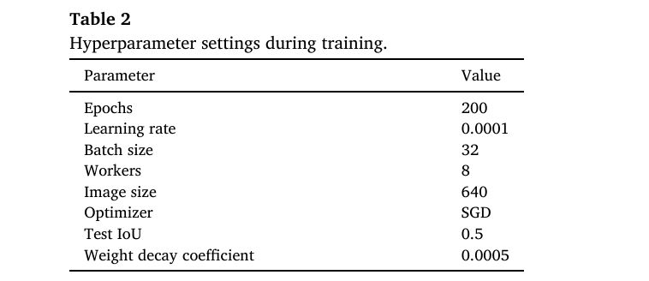
;l
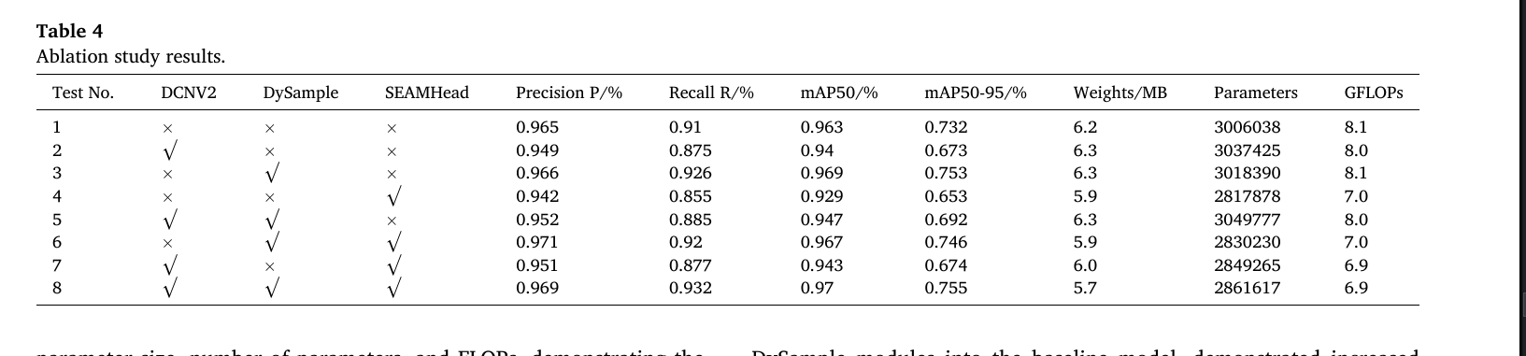

4.1. Justification for Selecting YOLOv8n as the baseline model

Although the YOLO series models share a broadly similar architec
ture, key differences in module design across versions significantly
impact their performance on small target detection tasks. The structural
innovations in YOLOv8n, particularly the replacement of the CSP block
with the C2f module, enhance gradient flow and reduce parameter
redundancy, effectively preserving micro-target features in complex
backgrounds. The SPPF module efficiently fuses multi-scale contextual
information at reduced computational costs, while also improving the
model’s capability to detect targets at different scales. The decoupled
head design further separates the learning paths for classification and
regression tasks, enhancing adaptability in small object detection.
By contrast, the SDDS module introduced in YOLOv10n aims to
enhance feature utilization and limit information loss, which benefits
global perception but has limited ability to preserve edge details critical
for small target detection. The C3k2 and C2PSA modules in YOLOv11n
improve computational efficiency through group convolution and
lightweight bottleneck structures, whereas the improvement in small
Table 6
Accelerated deployment model performance comparison.

Information Processing in Agriculture 12 (2025) 581–594
target detection tasks remains limited. YOLOv12n integrates the
BiFormer module to enhance global modeling capacity, which is bene
ficial for large targets and dense scenes. However, it has limited suit
ability for early-stage, small lesion detection, and it substantially
increases parameter counts and computational overhead.
Therefore, the architectural design of YOLOv8n strikes a better bal
ance between lightweight deployment, feature extraction capability,
and adaptability for embedded scenarios, which makes it a reasonable
baseline choice for this study. The comparative analysis and experi
mental results further validate the superior suitability of YOLOv8n for
small object detection tasks such as early-stage barley root mold
identification.
It is worth noting that although transformer-based models like RT-
DETR demonstrate competitive detection accuracy, their high compu
tational complexity and resource demands make them less suitable for
real-time, embedded deployment scenarios compared to YOLOv8n.

Paper-2

The existing mainstream target detection methods can be divided into two categories:
two-stage and single-stage. Two-stage methods such as R-CNN [5] and Faster R-CNN [6]
achieve high accuracy by first generating candidate regions and then performing classifica-
tion and regression, but the computational complexity is high; single-stage methods such as
SSD [7] and the YOLO series [8] directly locate and identify targets in an end-to-end manner.
With the advantages of simple structure, fast inference speed, and convenient deployment,
they are more suitable for resource-constrained agricultural automation scenarios. Since its
introduction in 2016, the YOLO series has been continuously iterated, gradually optimizing
the balance between detection accuracy, speed, and robustness.

Paper 3

. This
article explores in detail the lightweighting process of the YOLO v8 model, aiming to optimize its performance in resource
constrained environments by combining BN layer scale factor pruning and int8 quantization techniques under the TensorRT
framework.

